Read the case on Page 288-289 of the text. Answer the 3 questions listed below: Be sure to follow the format given in week one's example.
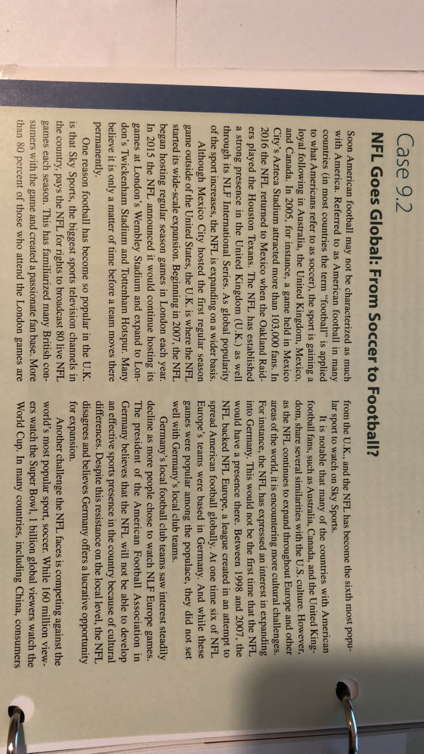
- Why do you think the NFL has an easier time expanding into countries such as the United Kingdom and Canada than countries such as Germany and China?
- Describe some of the global forces acting as barriers to the NFL as it expands globally.
- Do you think the NFL will have to customize the games it plays overseas to better fit with local cultures? Support your response.

